Testcase1:
Send an order of quantity 2 to a work station.
Send 4 Cancel requests to PAR, but do not apply the CANCEL.
Send the 5 th cancel request to PAR from the trader GUI,
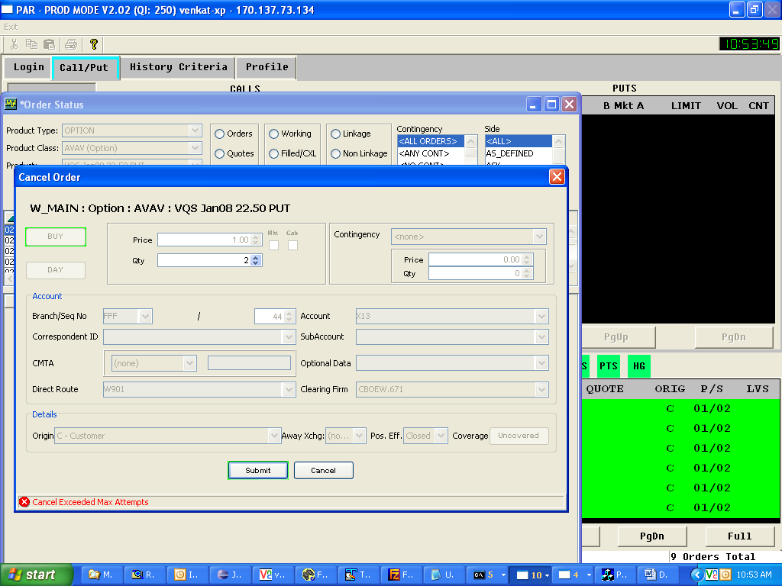
You will see the above message in the trader gui.
Count the number of Cancel requests in the order history. It should be 2 times the original quantity (4)
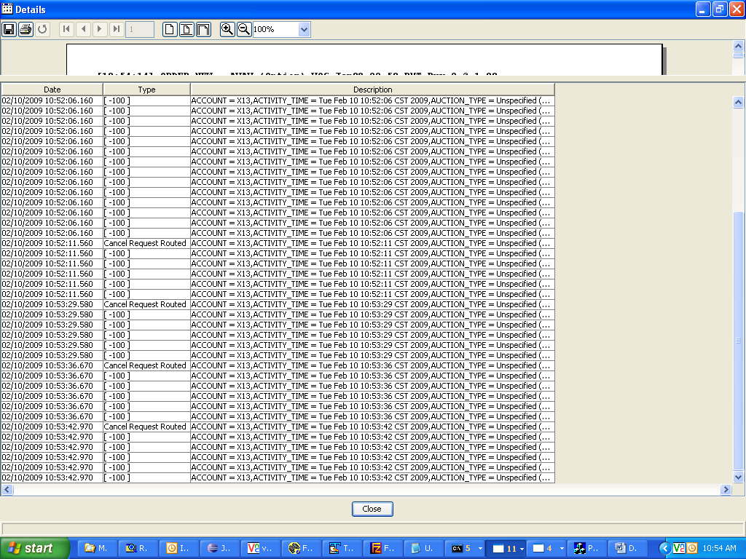
You should see the text message in the SA GUI message center as well
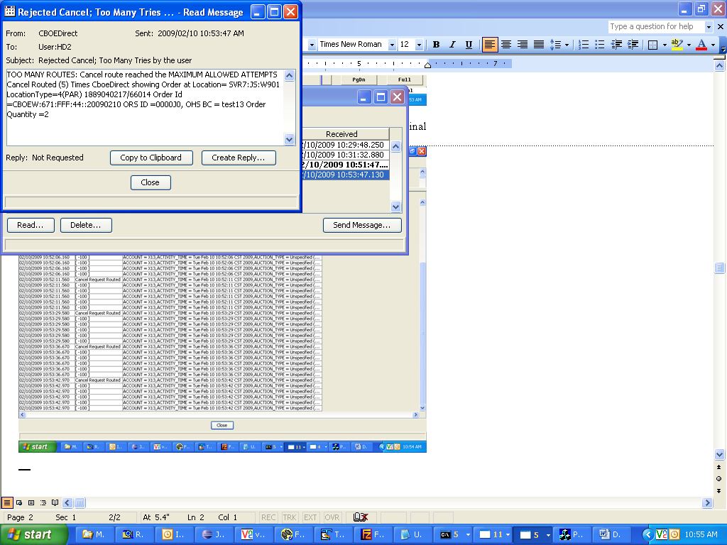

The text message should be sent only once to the Message center irrespective of how many times the cancel request (that exceeds the max count) is sent. Send in another cancel request and confirm that the message center does not keep getting this text.

Test Case2:
Repeat the testcase1 with cancel/replacing the order instead of canceling the order.
The results are the same. (Maximum allowed cancel replace should be 2 * the original quantity)
Also check that the message is generated in the message center only once.

Test case for order quantity fix:
Route an order with a quantity 99,999
This order should be accepted.

Route an order with quantity 100,000
This should be rejected.
